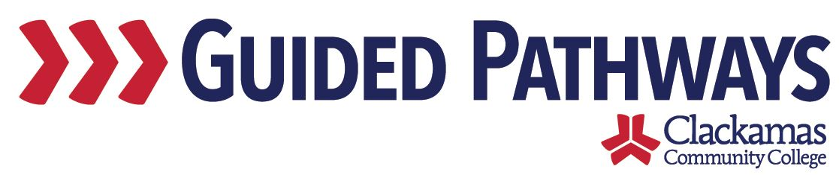
Guided Pathways Leadership Taskforce
Meeting Notes
November 2, 2020, 2:00–3:30 p.m. (Zoom)

- Follow up on previous commitments and updates
- Kelly had a commitment to revise the charter using the feedback from the last meeting – the group will be discussing the revised charter at today’s meeting

- Pre-College Work Group progress
- Would like to move away from Pre-College Workgroup and become the College Foundations Workgroup – this will be more inclusive and help make all students feel like they are a part of the college, because they are
- Marc shared his screen to show a Prezi
- Agreement that the terminology sounds more inclusive
- See these programs as feeder programs into degree and certificate programs
- How can we bring this forward with the other guided pathways materials so that students can see it – anchor each EFA with those support teams
- Jaime and Marc would like to get together with all of the leads at once and then have a deeper dive with each individual lead
- Will need Sue and Lisa’s help to learn where this information will live – to help students, staff, and faculty – like to be thinking about where this lives, what it looks like, as they meet with EFA leads
- Sue suggested that Jaime and Marc bring the presentation to the next EFA Development Network meeting
  - Jaime said that ideally that would happen sooner than December (when the EFA Development Network meets next)
- Marc said that the wheel graphic was adapted from Washington State

- Final review of charter
- Kelly shared the revised charter, using the feedback submitted from the October meeting
- Kelly made updates to the document in real time, utilizing additional feedback provided during the meeting

- Priorities and timeline for upcoming year
- Dawn shared the GPTF 2020-2021 Timeline
- Went through self-assessment and pulled out those items that we said we needed to continue to monitor or accomplish during this academic year – those were added into this timeline
- Broke into small groups for 25 minutes
- Each breakout room focused on one topic – discuss whether this is still a reasonable action item, review timeline
  - CAR
  - EFA
  - FYE
  - CF

- Review commitments and next steps
- Commitments and next steps were reviewed
- The next meeting of the Guided Pathways Taskforce is on Monday, December 7, 2:00-3:30 p.m.

